Assumptions and Limitations

# Assumptions

The main assumption made is regarding the presence of metadata in the audio files added to the playlist. The interface was built to requirements which state that there should be an option to display audio files by either Song Track or Album.

The interface reads the metadata from the track whilst inputting it to the playlist to output the Track Name and Album name – if the album name is missing from the metadata, this will show an error.

The same goes for album artwork and the song’s artist, which are read and populate the main player interface so the user can see them.

The below screenshot shows an audio file with the appropriate metadata including:

* Artist Name
* Album Name
* Album art/cover
* Track Name

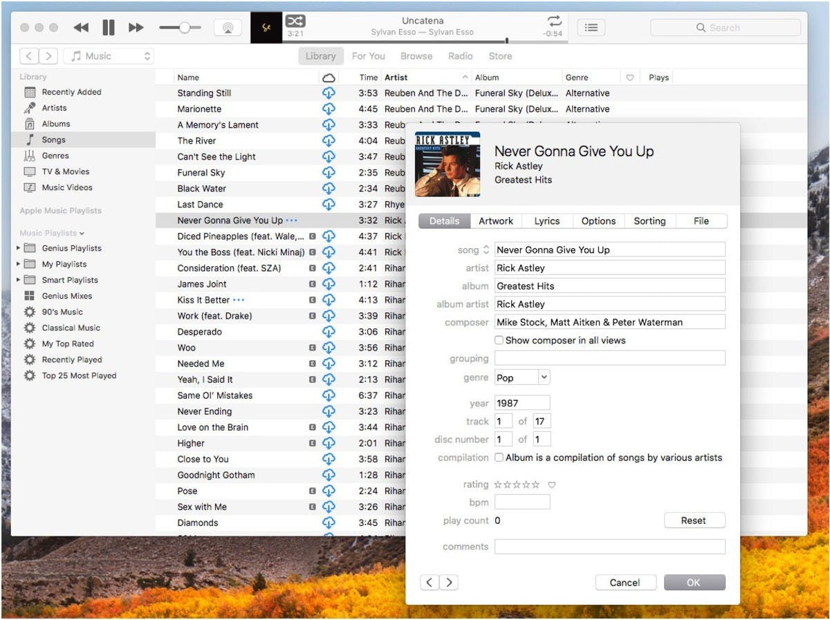

The other assumption is the user has loaded their audio files into the “music” directory inside the Build_v1 directory, ready for them to input to the interface.

# Limitations

The song input is limited by allowing only audio files to be pushed into the playlist. Choosing a format not mentioned in the Use Case will create an error.